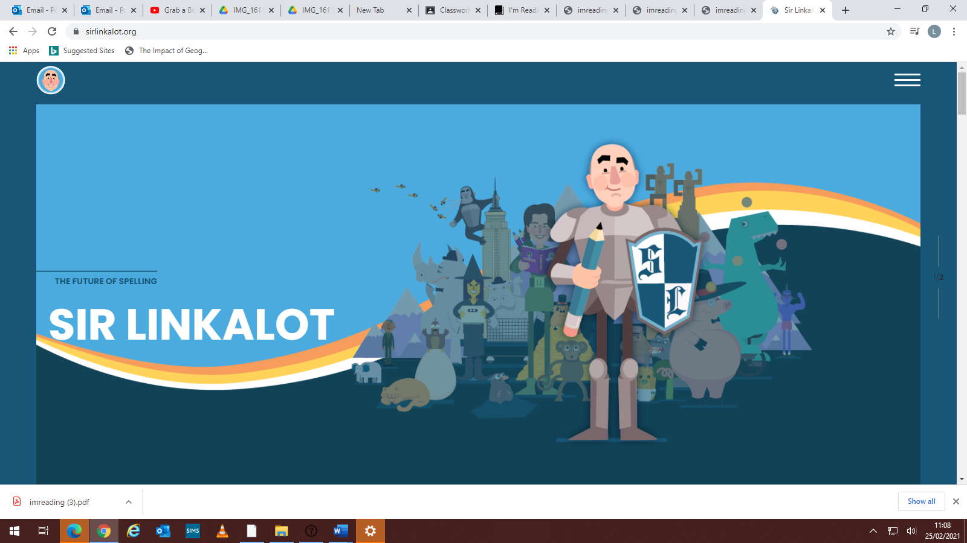

 Username: St Botolph’s  
The access code is MT96BX7E4JP

app.sirlinkalot.org