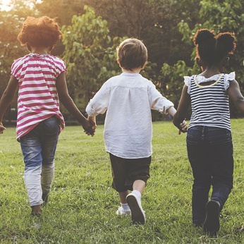Term 1 – Wonderful Me

This project supports children with settling into the new rules and routines of school and encourages them to make new friends and feel confident in their class. It teaches children about being helpful, kind and thoughtful at home and at school. This project also teaches children how they are unique and special, the importance of friendship and how people in their family, school and local community are important and can help them.

Focus areas of learning:

PD - Gross motor skills; Fine motor skills

PSED - Self-regulation; Managing self; Building relationships

World - Past and present; People culture and communities

Exp A&D - Creating with materials; Being imaginative and expressive

CL - Listening, attention and understanding; Speaking