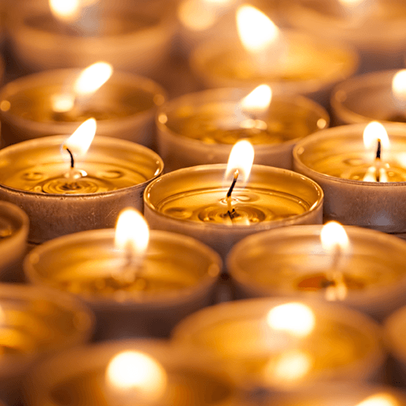Term 2 – Celebrations

This project teaches children about the celebrations that take place during the autumn and winter seasons and focuses on the significance and symbolism of light at this time of year.

Focus areas of learning:
PD - Gross motor skills; Fine motor skills
PSED - Self-regulation; Managing self; Building relationships
World - People culture and communities; The natural world
Exp A&D - Creating with materials; Being imaginative and expressive
CL - Listening, attention and understanding; Speaking

