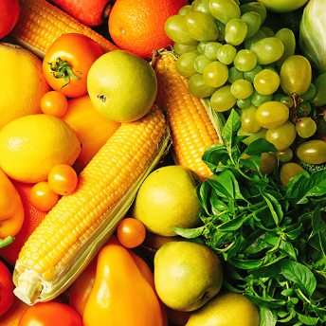 Term 5 – Ready Steady Grow

This project teaches children about food and farming and explores themes, including where food comes from, what plants and animals need to grow and survive and what constitutes a healthy lifestyle.

Focus areas of learning:
PD - Gross motor skills; Fine motor skills
PSED - Self-regulation; Managing self; Building relationships
World - Past and present; People, culture and communities; The natural world
Exp A&D - Creating with materials; Being imaginative and expressive
CL - Listening, attention and understanding; Speaking
Literacy - Comprehension; Word reading; Writing

